Project Report

**“Employee Management System for Engineering Library Organization”**

**Developed**

**By**

**“SHUBHAM SAGAR, Computer Science & Engineering, ROLL Number: 25”**

Under the guidance of

**Dolan Chakraborty** 

DEPARTMENT OF COMPUTER SCIENCE & ENGINEERING

## NETAJI SUBHASH ENGINEERING COLLEGE

**TECHNO CITY, GARIA, KOLKATA – 700 152**

**CERTIFICATE**

This is to certify that this project report titled **Employee Management System for Engineering Library Organization** submitted in partial fulfillment of requirements for award of the degree Bachelor of Technology (B. Tech) in Computer Science & Engineering of MAULANA ABUL KALAM AZAD UNIVERSITY OF TECHNOLOGY is a faithful record of the original work carried out by,

**Shubham Sagar, Roll no. 10900116049, Regd. No. 161090110102 (2016-17)**

under my guidance and supervision.

It is further certified that it contains no material, which to a substantial extent has been submitted for the award of any degree/diploma in any institute or has been published in any form, except the assistances drawn from other sources, for which due acknowledgement has been made.

___________

##### Date:……….. Guide’s signature

**(Dolan Chakraborty)**

**DECLARATION**

##### We hereby declare that this project report titled

##### **Employee Management System for Engineering Library Organization**

##### is our own original work carried out as a under graduate student in Netaji Subhash Engineering College except to the extent that assistance from other sources are duly acknowledged.

##### All sources used for this project report have been fully and properly cited. It contains no material which to a substantial extent has been submitted for the award of any degree/diploma in any institute or has been published in any form, except where due acknowledgment is made.

##### Student’s name: Signature: Date:

##### SHUBHAM SAGAR ……………………….. 09th May 2018

**ACKNOWLEDGMENT**

I owe my deep sense of gratitude to my respected supervisor Dolan Chakraborty,

Prof.,Dolan Chakraborty, Department of Computer Science & Engineering, Netaji Subhash Engineering College, Kolkata for his meticulous and expert guidance, constructive criticism, patient hearing and benevolent behavior throughout my ordeal of the present research. I shall remain grateful to him for his cordial, cooperative attitude, wise and knowledgeable counsel that acted as an impetus in the successful completion of my project titled **Employee Management System for Engineering Library Organization.**

I would like to particularly thank the Head of the Department Prof., Atanu for giving me guidance and inspiration during my study in the department. I never forget the kind help extended by the HOD. It however, is not possible for me to forget the kind of help provided by all the faculty members,

At last but not least my friends in the department who deserve some words of thanks.

Dated: 09th May 2018

**CONTENTS**

|  |  |
| --- | --- |
| Acknowledgement | 04 |
| Abstract | **06** |
| Introduction | **07** |
| Project Scope | **08** |
| Software Requirement   * General Description * Overall Description | **10** |
| Data Flow Diagram | **12** |
| Software Layout | **13** |
| Running Mode | **17** |
| Application Coding | **22** |

**ABSTRACT**

The project is based on an application which eases the work of data of the employee working in the organization named “Engineering Library”. It contains vast information for the user. The user id, Password, Name, post, Date of joining, Salary are contained in it. It can hold an indefinite number of employee information. At any time or at any moment the data related to an employee can be edited without any haste. Not only that the information can be edited, it is also possible to search any user information except password by only putting their user id. The application is not only user-friendly but also good at it resources.

**INTRODUCTION**

This Application is used to manage and search the employee details with regard to employee name and their salary. The user can search all recorded details of an employee except password. This document is meant to delineate the features of Employee management system application, so as to serve as guidelines to the developers on first hand and the software validation document for the client on the other.

## Project Scope:

This application is developed for users who wish to access, edit, search or modify the employee details by knowing username and password of the user about whom the information is to be accessed.

The Application provides functionality on following platforms

* Windows XP
* Windows Vista
* Windows 7
* Windows 8
* Windows 10

**Benefits:**

The benefit of this application is very normal, it can be used anytime when Employee wants to add, remove, edit, search or modify employee details.

**Scope:**

The scope of this application cannot be considered too wide or too narrow the factor defining its scope is its volume of data storage and as the way to use this application is very easy and understandable therefore anyone can use it without any problem.

**Purpose/objective**

The purpose of this application is to add, modify, delete, search employee details of the various person who is working in the organization along with their salary and date of joining.

**Limitations:**

The only limitation of this application is the feature of taking or say requirement of any single detail key without which no further function can be done in the application.

**Functional Test**

Functional test can be defined as testing two or more modules together with the intent of finding defects, demonstrating that defects are not present, verifying that the module performs its intended functions as stated in the specification and establishing confidence that a program does what it is supposed to do.

**SOFTWARE REQUIREMENTS SPECIFICATION**

**For**

**Employee Management System**

## Glossary:

|  |  |
| --- | --- |
| Term | Definition |
| DOJ | Date of joining of the Employee in the organization. |
| Search Engine | Engine used to search employee information. |
| Personal information | Data including all details of the employee except password. |

* 1. References:
* Head First Book of Visual Basic
* Microsoft Developer’s Network forum
* www.quora.com

# General Description

This is fast software that can be used to access any information recorded in the records of organization database by user id. This creates vast data storage software. You can keep as many as employee details with its full details that can be accessed any time by user id and password. Different employee can be identified easily with their different user id. Any employee can access the application except password.

# The Overall Description

Anybody can easily find the employee details recorded in the directory using user id and can be access or edited by entering password of that employee. This application provides a vast recording capacity to store employee details with salary, DOJ and other details. When a user wants to use the system he/she is asked for any of the recorded detail and then they can search full details very comfortably except password. This application helps the user a lot to draw any information about the employee. The interface, which includes simple employee details for no reason other than to provide them to you whenever you want, would be better served by a more standard layout that makes options readily and easily available. In our tests, the program demonstrated good speed, even when accessing. If you require this information and need to edit, remove, add or search them, you should definitely give employee directory a try.

## Product Perspective

This project is independent, unique, and self-contained.

## Product functions

1. Add, remove, edit, update employee details.
2. Enter the user id and password for updating the details of particular employee.
3. Search the recorded employee details by their user id.

## Operating Environment:

Software Platform:

1) Visual Basic studio 6.0

2) Microsoft Access

## System Requirements

* Windows XP or Higher Version of windows

**Minimum Hardware configuration**

* CORE2DUO
* Ram 1GB
* Hard disk about 50Mb

**DATA FLOW DIAGRAMS**

Employee management System(Home)

Employee

Details

* **SOFTWARE LAYOUT**
* **Home**

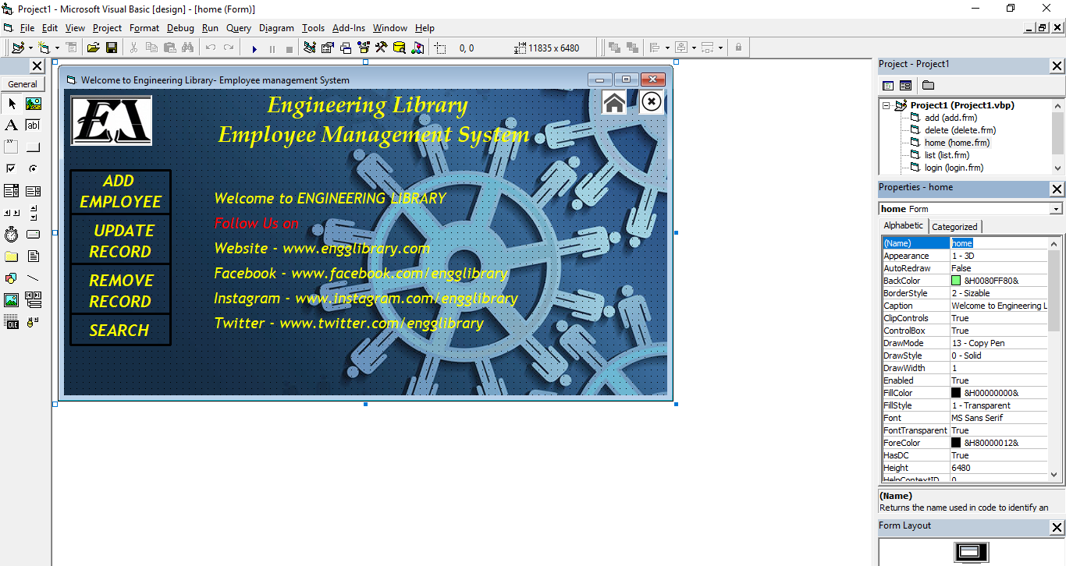

* **Add Employee**

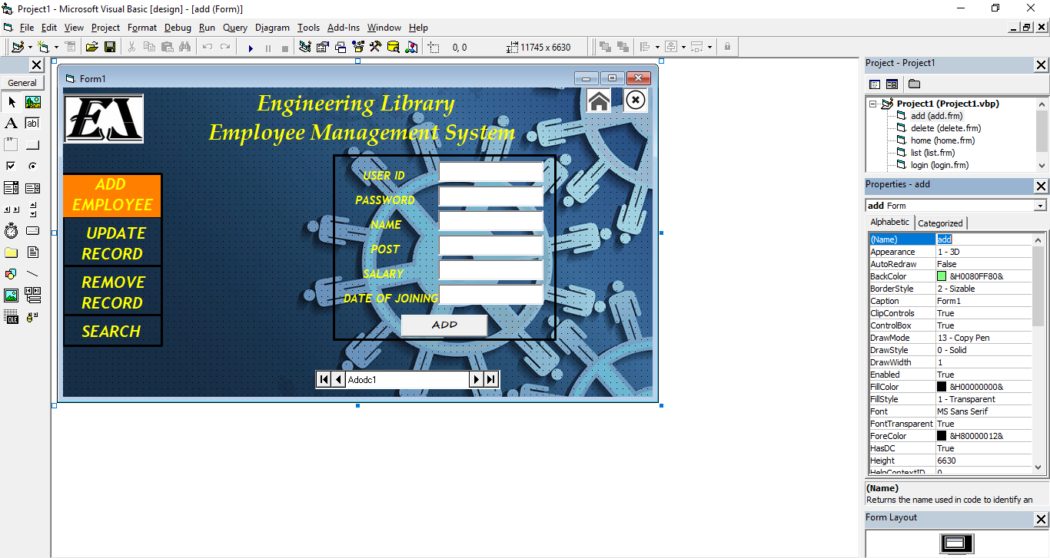

* **Delete Employee**

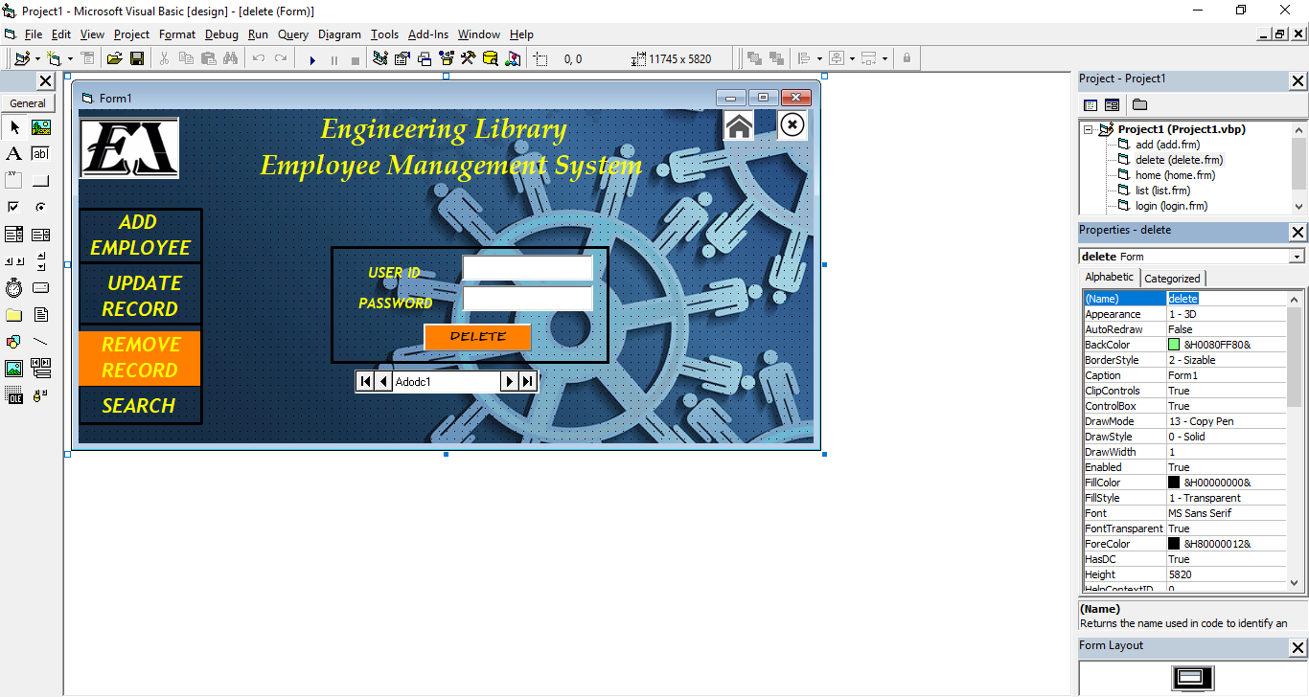

* **Search Employee**

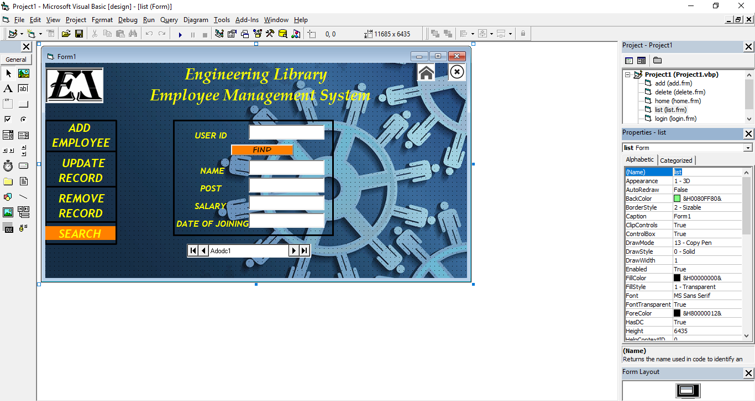

* **Update Employee**

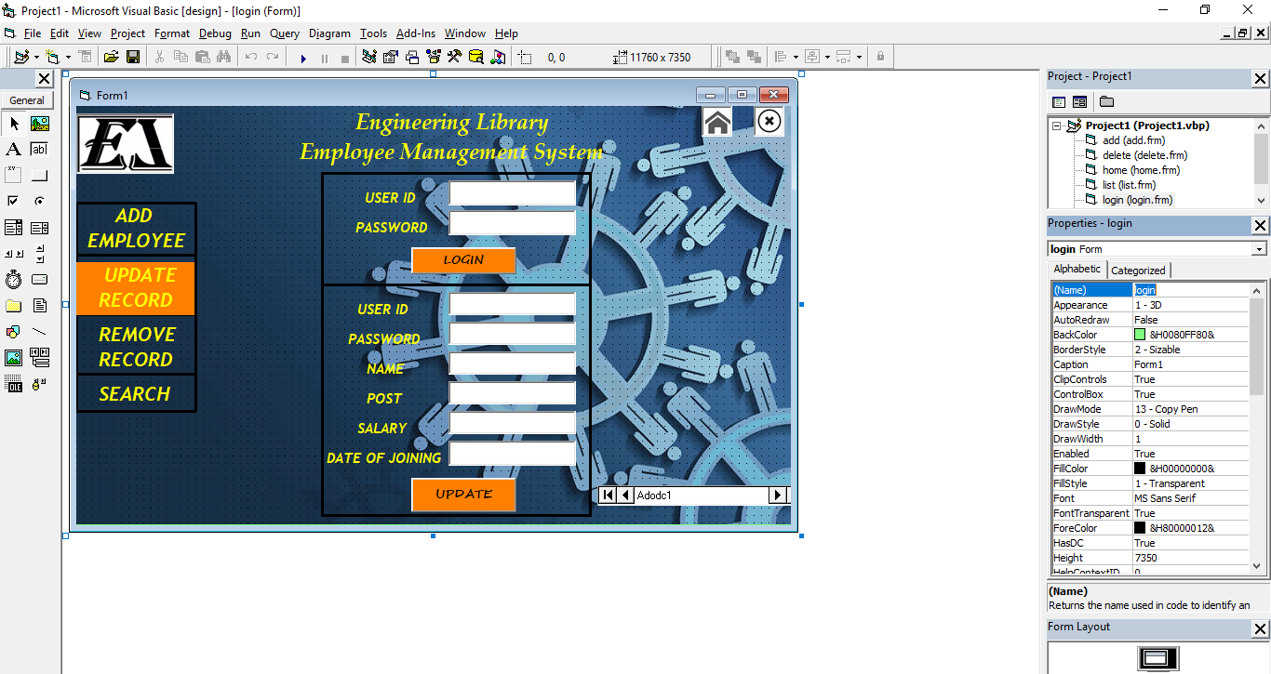

* **DataBase**

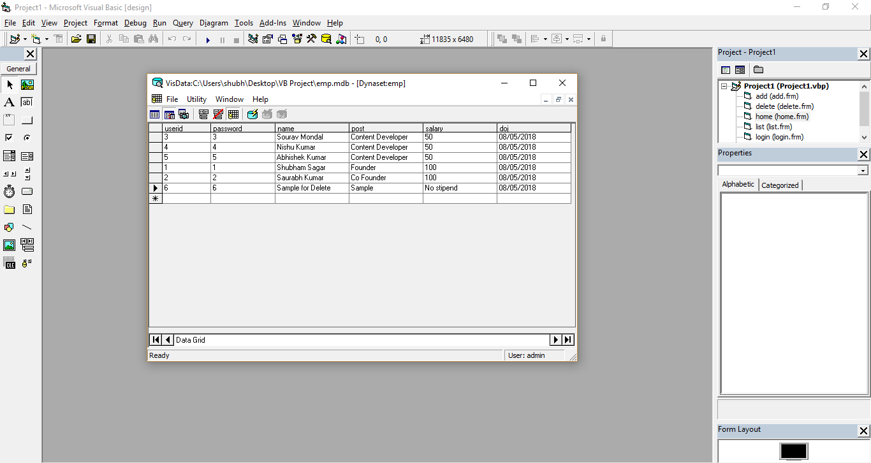

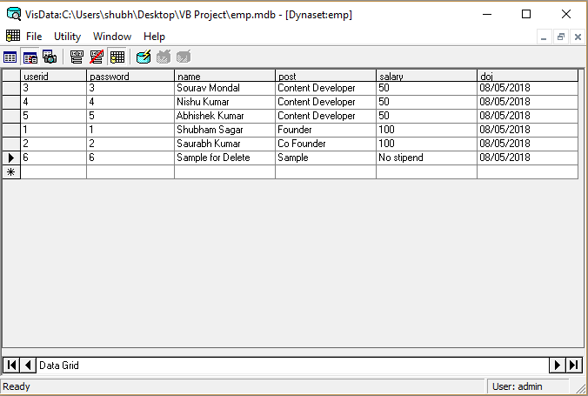

* **RUNNING MODE**

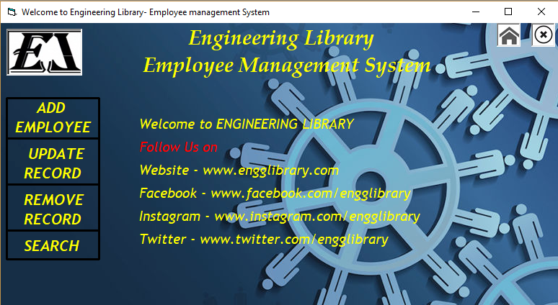

* **Add Employee**

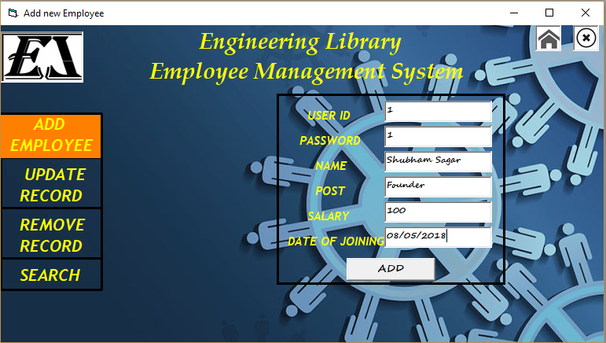

* **Update Employee**

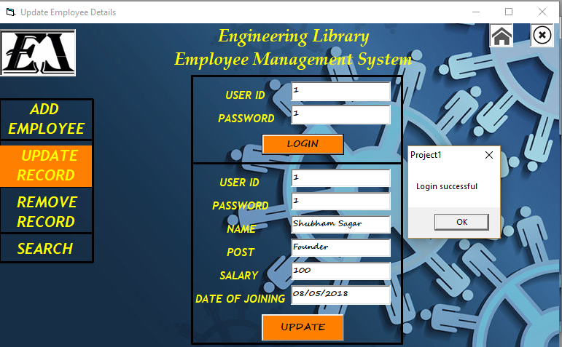

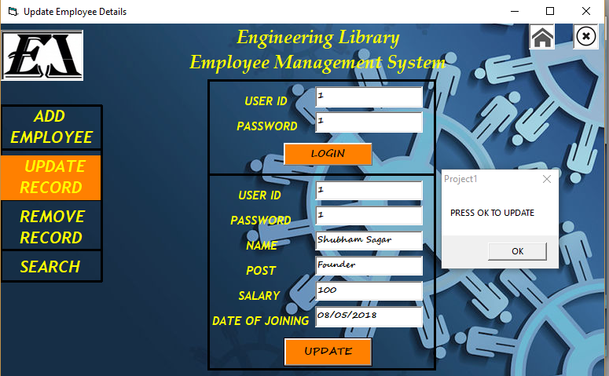

* **Data Updated**

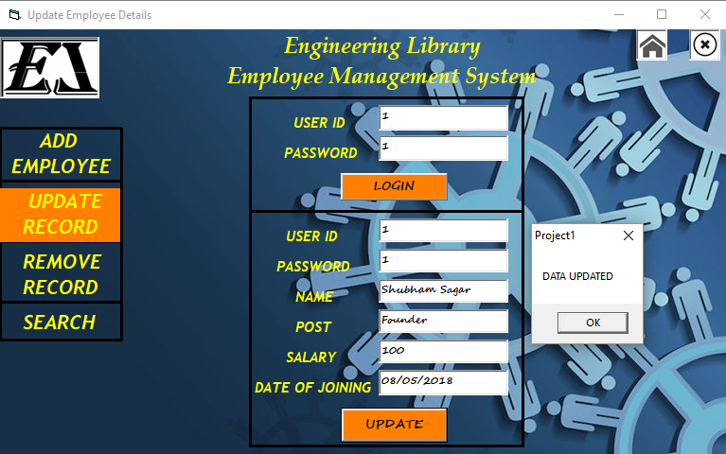

* **DELETED**

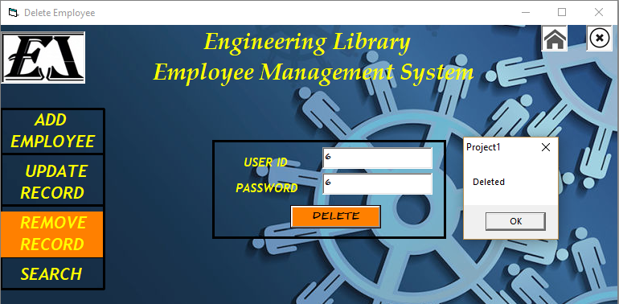

* **Search Employee**

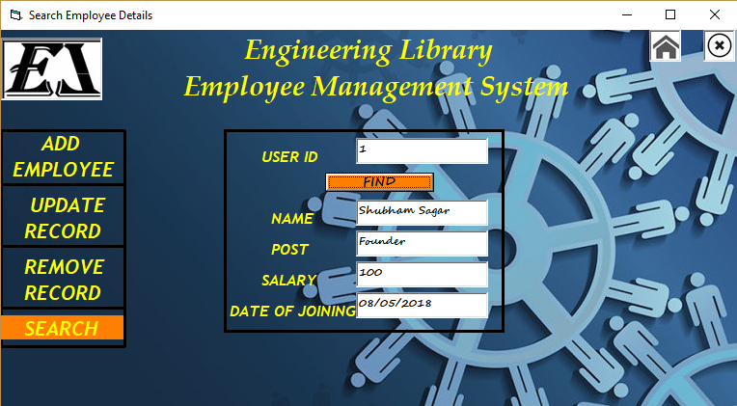

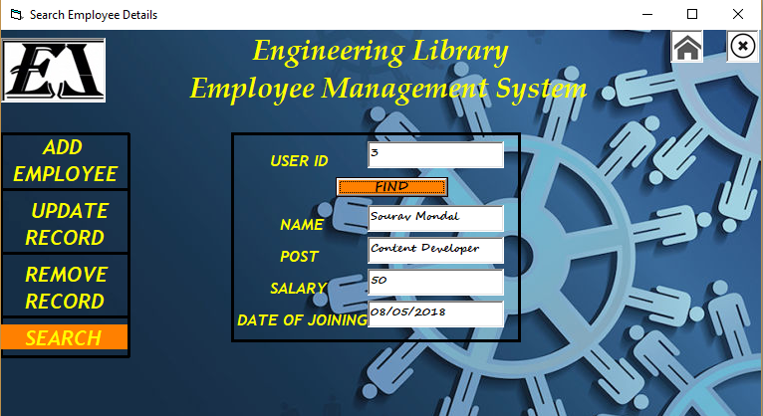

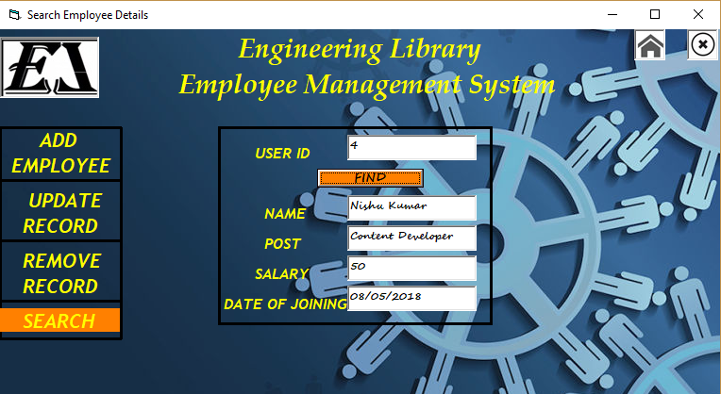

**APPLICATION CODING**

* **HOME**

Private Sub Label2_Click()

home.Visible = False

add.Visible = True

End Sub

Private Sub Label3_Click()

home.Visible = False

login.Visible = True

End Sub

Private Sub Label4_Click()

home.Visible = False

delete.Visible = True

End Sub

Private Sub Label5_Click()

home.Visible = False

list.Visible = True

End Sub

Private Sub Picture2_Click()

End

End Sub

Private Sub Picture3_Click()

home.Visible = True

End Sub

* **ADD EMPLOYEE**

Private Sub Command1_Click()

a1.Recordset.AddNew

End Sub

Private Sub Label10_Click()

home.Visible = False

login.Visible = True

End Sub

Private Sub Label8_Click()

home.Visible = False

list.Visible = True

End Sub

Private Sub Label9_Click()

home.Visible = False

delete.Visible = True

End Sub

Private Sub Picture2_Click()

End

End Sub

Private Sub Picture3_Click()

home.Visible = True

End Sub

* **DELETE EMPLOYEE**

Dim f As Integer

Private Sub Command1_Click()

'If a1.Recordset.Fields(0) = Text1.Text And a1.Recordset.Fields(1) = Text2.Text Then

'f = 0

a1.Recordset.MoveFirst

Do While Not a1.Recordset.EOF = True

If a1.Recordset.Fields(0) = Text1.Text And a1.Recordset.Fields(1) = Text2.Text Then

a1.Recordset.delete

a1.Recordset.Requery

MsgBox "Deleted"

f = 1

Exit Do

Else

a1.Recordset.MoveNext

End If

Loop

If f = 0 Then

MsgBox "Not Found"

End If

'Else

'MsgBox "NOT FOUND"

'End If

End Sub

Private Sub Form_Load()

f = 0

End Sub

Private Sub Label5_Click()

home.Visible = False

list.Visible = True

End Sub

Private Sub Label6_Click()

home.Visible = False

login.Visible = True

End Sub

Private Sub Label7_Click()

home.Visible = False

add.Visible = True

End Sub

Private Sub Picture2_Click()

End

End Sub

Private Sub Picture3_Click()

home.Visible = True

End Sub

* **SEARCH EMPLOYEE**

Dim f As Integer

Private Sub Command1_Click()

f = 0

a1.Recordset.MoveFirst

Do While Not a1.Recordset.EOF = True

If a1.Recordset.Fields(0) = Text1.Text Then

Text3.Text = a1.Recordset.Fields(2)

Text4.Text = a1.Recordset.Fields(3)

Text5.Text = a1.Recordset.Fields(4)

Text6.Text = a1.Recordset.Fields(5)

f = 1

Exit Do

Else

a1.Recordset.MoveNext

End If

Loop

If f = 0 Then

MsgBox "Not Found"

End If

End Sub

Private Sub Label10_Click()

home.Visible = False

add.Visible = True

End Sub

Private Sub Label8_Click()

home.Visible = False

delete.Visible = True

End Sub

Private Sub Label9_Click()

home.Visible = False

login.Visible = True

End Sub

Private Sub Picture2_Click()

End

End Sub

Private Sub Picture3_Click()

home.Visible = True

End Sub

* **UPDATE EMPLOYEE DETAILS**

Dim f As Integer

Private Sub Command1_Click()

'If a1.Recordset.Fields(0) = Text1.Text And a1.Recordset.Fields(1) = Text2.Text Then

'MsgBox "Login successful"

'f = 0

a1.Recordset.MoveFirst

Do While Not a1.Recordset.EOF = True

If a1.Recordset.Fields(0) = Text1.Text And a1.Recordset.Fields(1) = Text2.Text Then

MsgBox "Login successful"

Text8.Text = a1.Recordset.Fields(0)

Text7.Text = a1.Recordset.Fields(1)

Text3.Text = a1.Recordset.Fields(2)

Text4.Text = a1.Recordset.Fields(3)

Text6.Text = a1.Recordset.Fields(5)

Text5.Text = a1.Recordset.Fields(4)

f = 1

Exit Do

Else

a1.Recordset.MoveNext

End If

Loop

If f = 0 Then

MsgBox "USERNAME or PASSWORD INCRRECT"

End If

'Else

'MsgBox "USERNAME / PASSWORD INCRRECT"

'End If

End Sub

Private Sub Command2_Click()

a1.Recordset.MoveFirst

Do While Not a1.Recordset.EOF = True

If a1.Recordset.Fields(0) = Text1.Text And a1.Recordset.Fields(1) = Text2.Text Then

MsgBox "PRESS OK TO UPDATE"

a1.Recordset.Fields(0) = Text8.Text

a1.Recordset.Fields(1) = Text7.Text

a1.Recordset.Fields(2) = Text3.Text

a1.Recordset.Fields(3) = Text4.Text

a1.Recordset.Fields(5) = Text6.Text

a1.Recordset.Fields(4) = Text5.Text

f = 1

Exit Do

Else

a1.Recordset.MoveNext

End If

Loop

If f = 0 Then

MsgBox "USERNAME or PASSWORD INCORRECT"

Else

MsgBox "DATA UPDATED"

End If

'End If

End Sub

Private Sub Label10_Click()

home.Visible = False

list.Visible = True

End Sub

Private Sub Label11_Click()

home.Visible = False

delete.Visible = True

End Sub

Private Sub Label13_Click()

home.Visible = False

add.Visible = True

End Sub

Private Sub Picture2_Click()

End

End Sub

Private Sub Picture3_Click()

home.Visible = True

End Sub